sharknado Games Inc.
Shark Attack 3: In Space
The sharks are back, but now in space
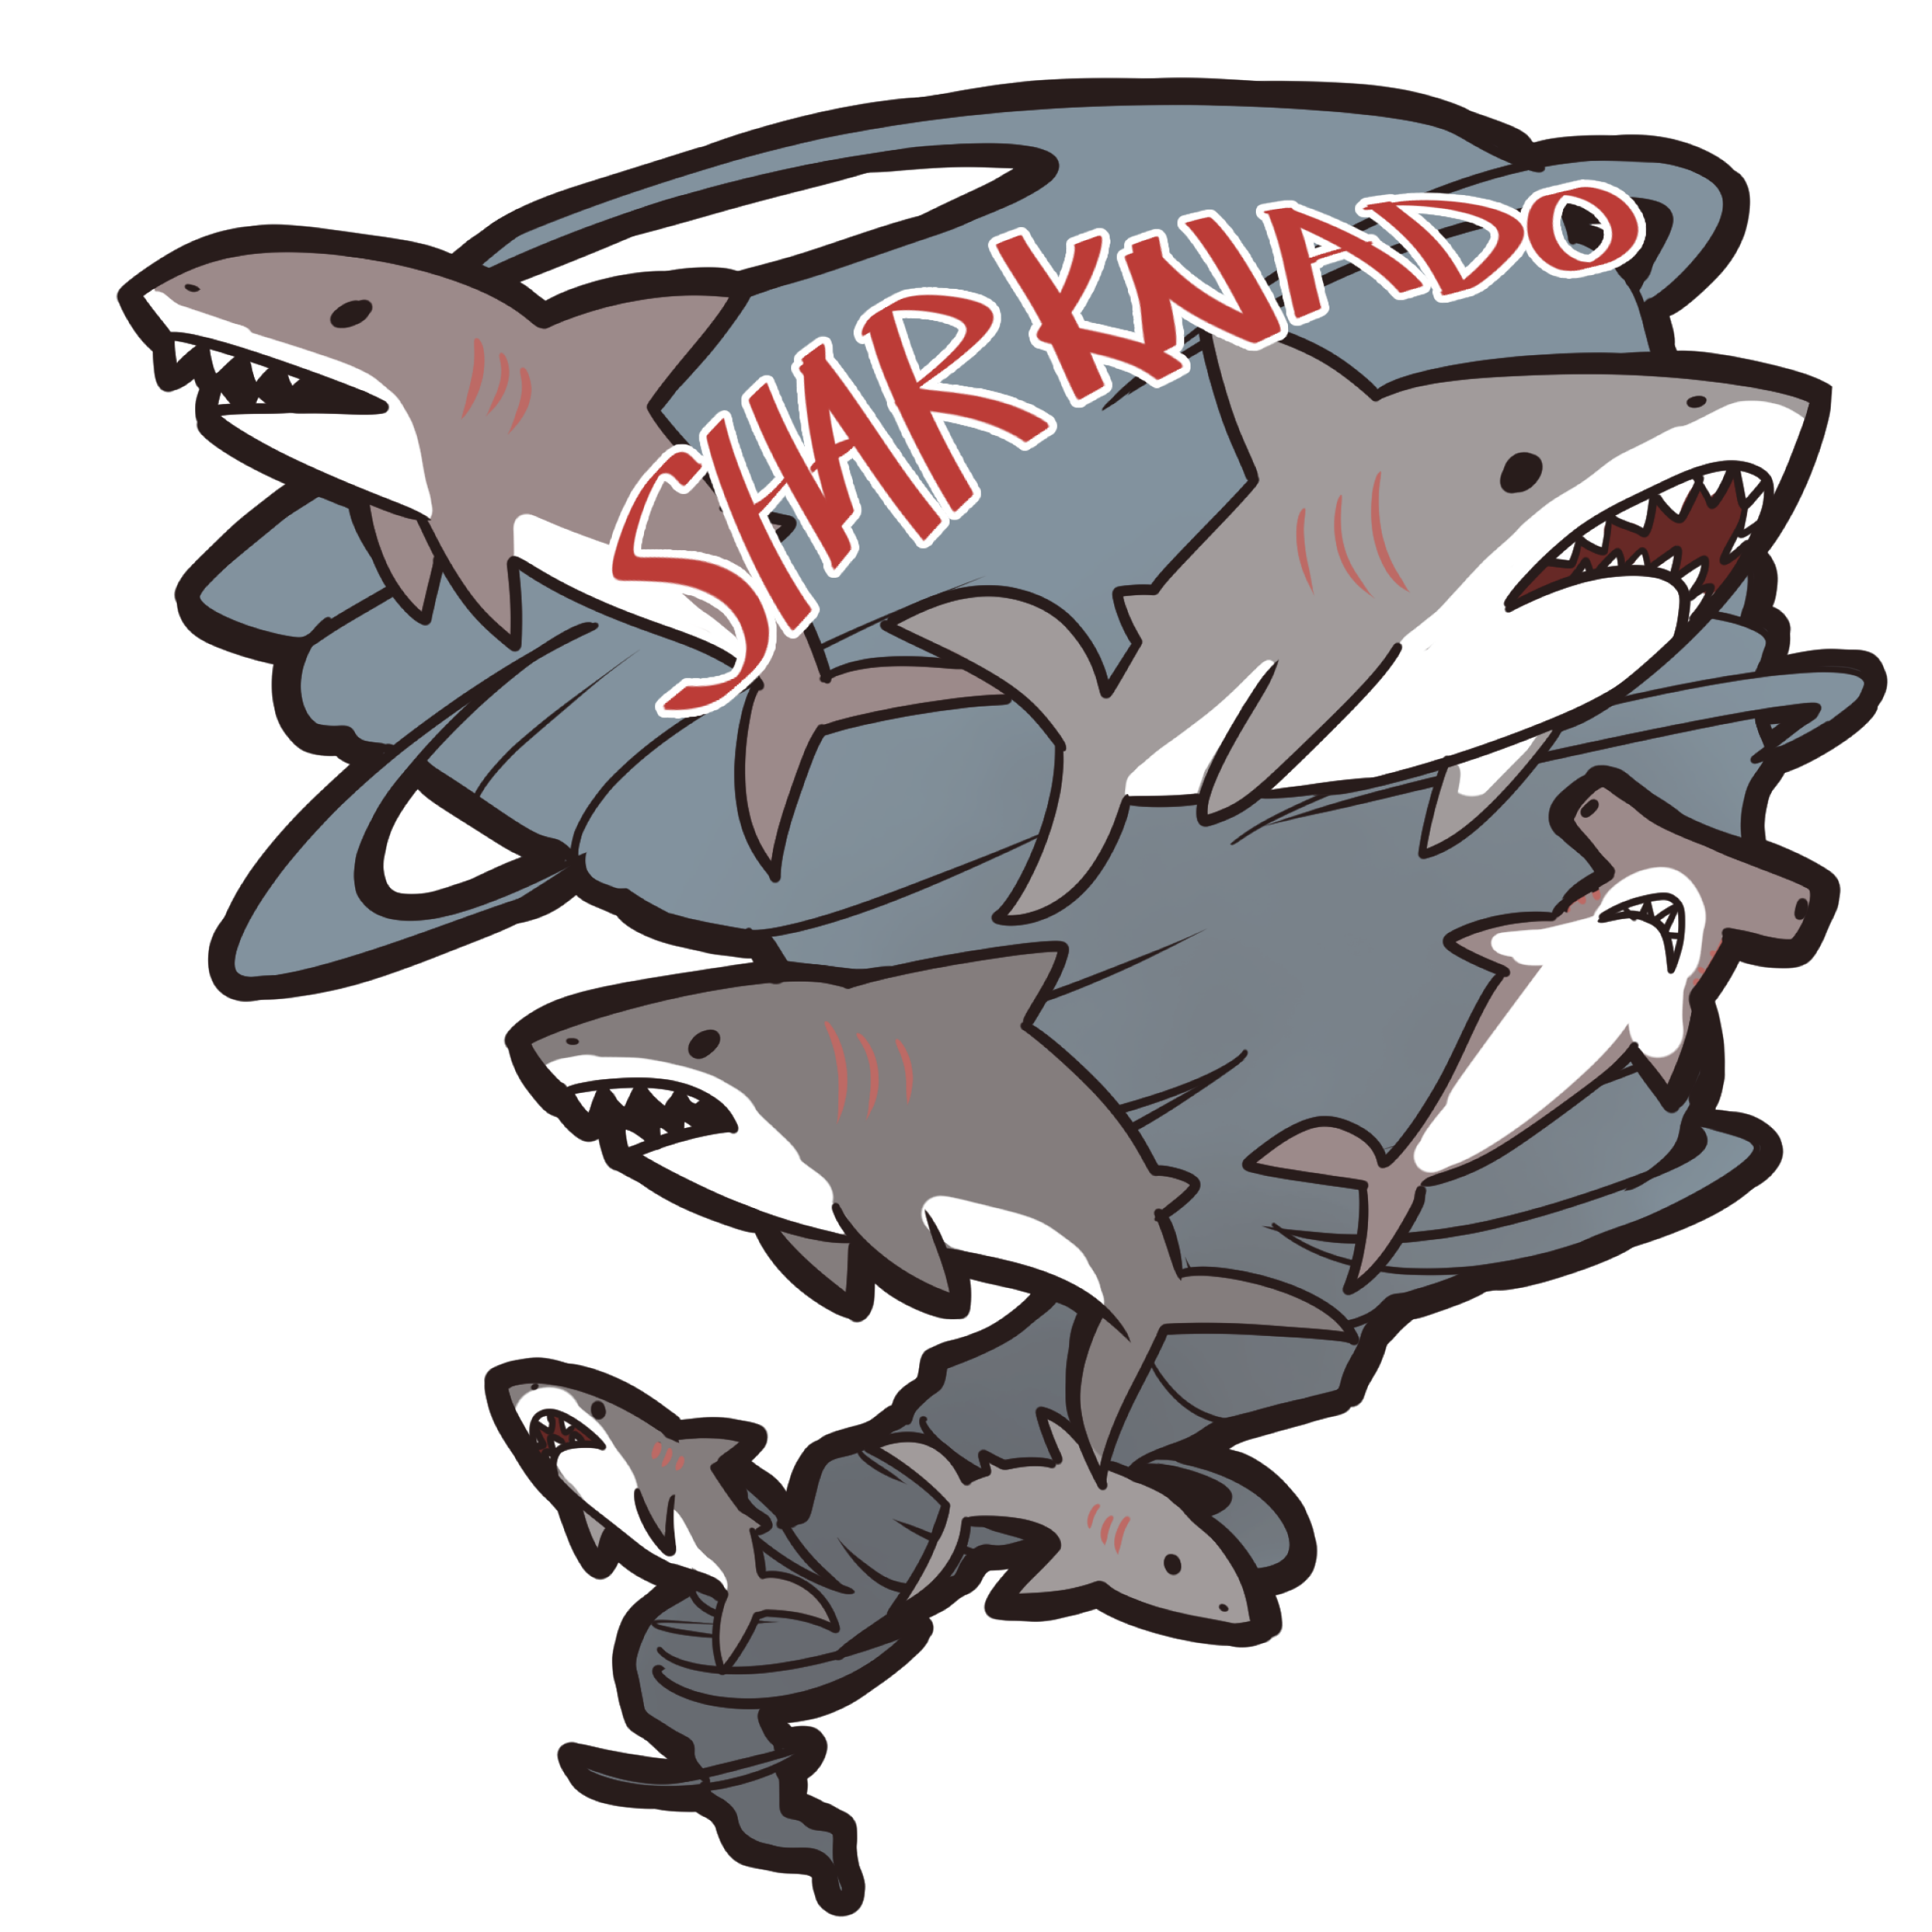
Version #1.0

All work Copyright © 2016 by Sharknado Games.
All rights reserved.

Aaron Fernandes, Arlina Ramrattan, Neil Reading & Omid Khataee

16-Aug-1

Contents
Version History 4
V0.1 4
V0.2 4
V0.3 4
Design Analysis 5
Detailed Game Description 5
Controls 5
Interface Sketch 5
Menu Screen 5
Instruction Screen 5
Level 1 6
Level 2 6
Level 3 6
Losing Screen 6
Winning Screen 7
Game World 7
Levels 7
Level 1 7
Level 2 7
Level 3 7
Characters 7
Enemies 7
Weapons 7
Vehicles 7
Scoring 7
Level 1 7
Level 2 8
Level 3 8
Screen Shots 8
Menu Scene 8
Instruction Scene 8
Level 1 8
Transition 1 8
Level 2 9
Transition 2 9
Level 3 9
Losing Scene 9
Winning Scene 9
Sound Index 10
Level 1 10
Level 2 10
Level 3 10
Art/Multimedia Index 10
Level 1 10
Level 2 10
Level 3 10
Button Images 11
Game Link 11

Version History
Github version link: https://github.com/aagavin/HTML5-Final/commits/develop

V0.1
- added first level
- added readme.md
- added first level to ref.ts
- changed title
- remoted unneeded files
- bg asset
- made Scene an enum
- added levels 1,2, and 3
- fixed menu

V0.2
- Added all references and links
- Added player for L1
- Added different treasure
- Added bullet class and functionality
- Added collisions between player and shark, player and heart, and bullet and shark
- Added functionality for level changing to L2
- Made and added new background
- Changed Background
- Changed player and bullet
- Added InjuredPeople class
- Changed treasure to injured people
- Added change level to level 3

V0.3
- stop sound
- updated boss live count
- Updated external document to part 2
- centering stuff
- bubbles removed
- changes from develop

Design Analysis

Detailed Game Description
The Sharks have attack again, this time in space! Your goal as the player is to battle your way through the levels and destroy the Shark’s leader and army. Level 1 is where you will be battling the defence Sharks on your way to the ship. Level 2 starts when you get to the ship, now you have to find your way through the ship to where the Leader is while saving the injured people. And then finally, level 3, is where you face the Shark Leader.
The player is a cop who believes the sharks are invading and no one believes him so he takes his trusty laser gun and fights them himself.

Controls
Shark Attack 3 uses a mouse to direct whether the cop moves up or down. The cop cannot be moved left or right. The laser can be shot with clicking the left button on the mouse.

Interface Sketch

Menu Screen
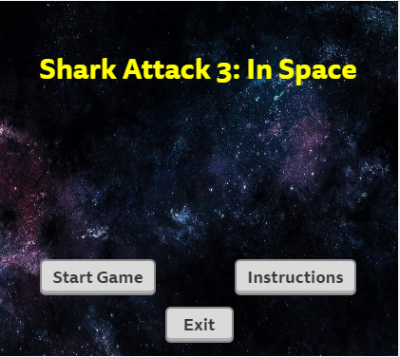

Instruction Screen
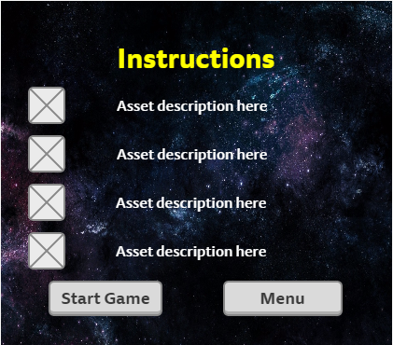

Level 1
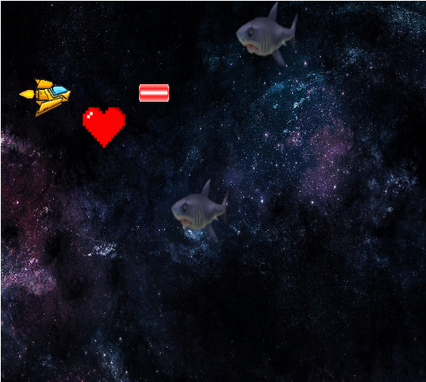

Level 2
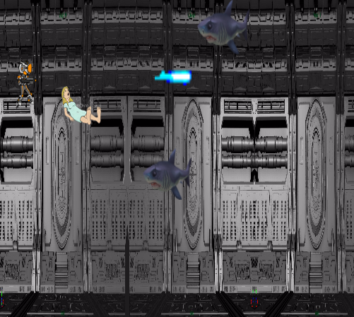

Level 3
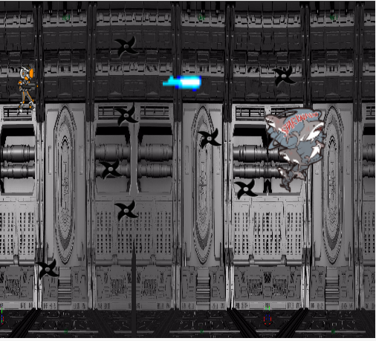

Losing Screen
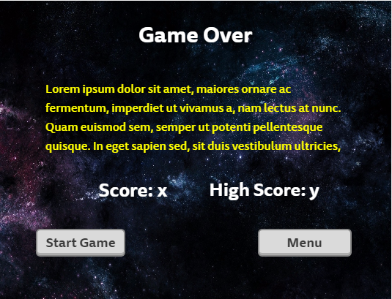

Winning Screen
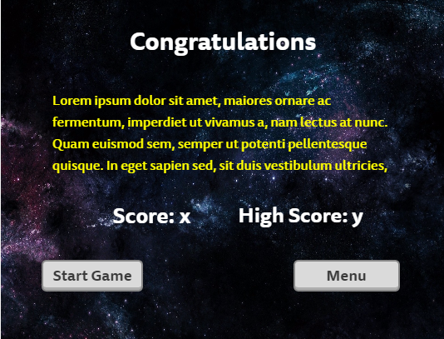

Game World
The game is taking place in outer space just beyond the outskirts of our planet.

Levels

Level 1
The player just got out of the earths atmosphere and is facing the defenders of the Shark army. Goal: to reach the ship with minimal damage

Level 2
The player has entered the ship and now has to fight the remaining forces while tying to get to the Shark Leader.

Level 3
The player has made it to the Leader and now has to win against them.

Characters
The avatar is a cop, trying to defend the earth from an invading Shark army.

Enemies
The enemies in this game are sharks. They move right to left and sometimes drift up or down. You lose lives if you get bitten.

Weapons
The player will only have access to a laser gun, which can be shot with the left click of the mouse.

Vehicles
The player will be in a spaceship but only for the first level.

Scoring

Level 1
To pass level 1 you need to kill 30 sharks, with each shark worth 10 points. The player has chances to regain lost lives by collecting a heart, but cannot exceed 10 lives.

Level 2
To pass level 2 you need to save 10 people, with each save worth 10 points. The player can also kill sharks, each worth 10 points.

Level 3
There is no scoring in level 3 but you must kill the end boss.

Screen Shots

Menu Scene
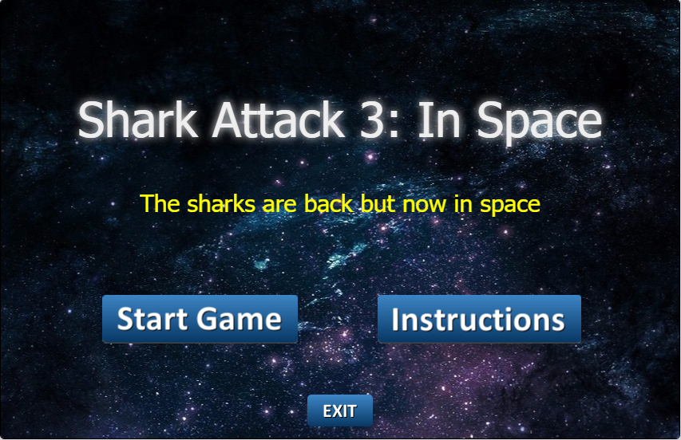

Instruction Scene
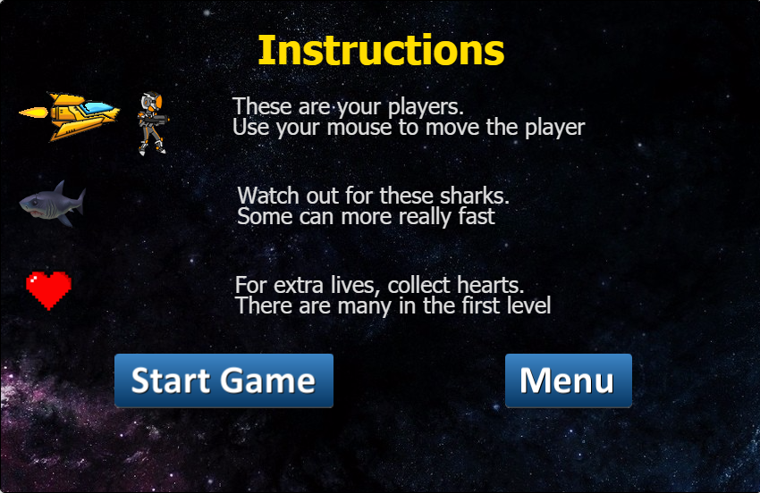

Level 1
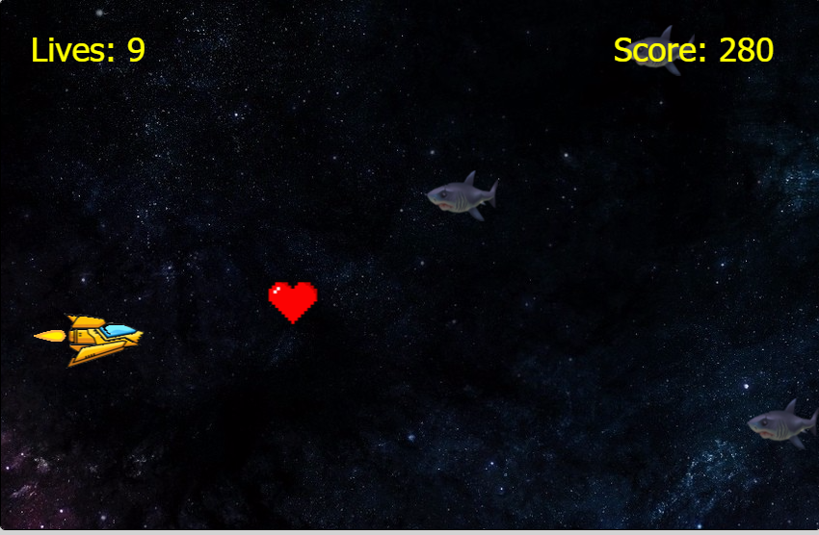

Transition 1
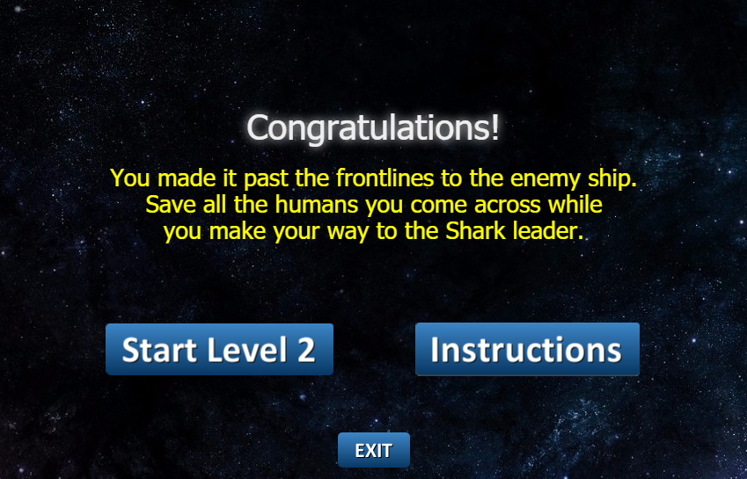

Level 2
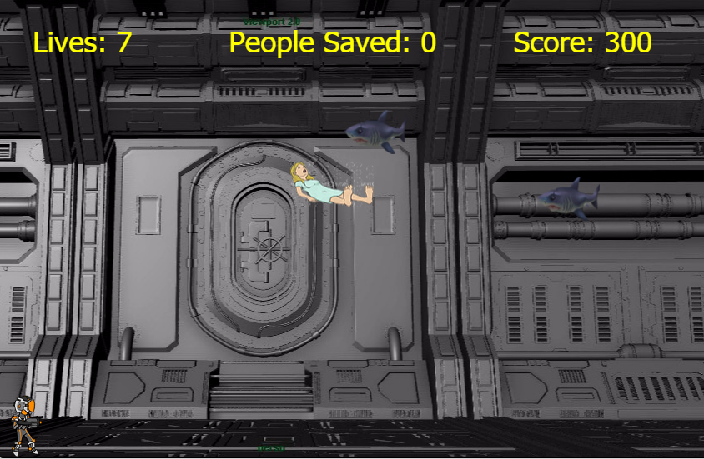

Transition 2
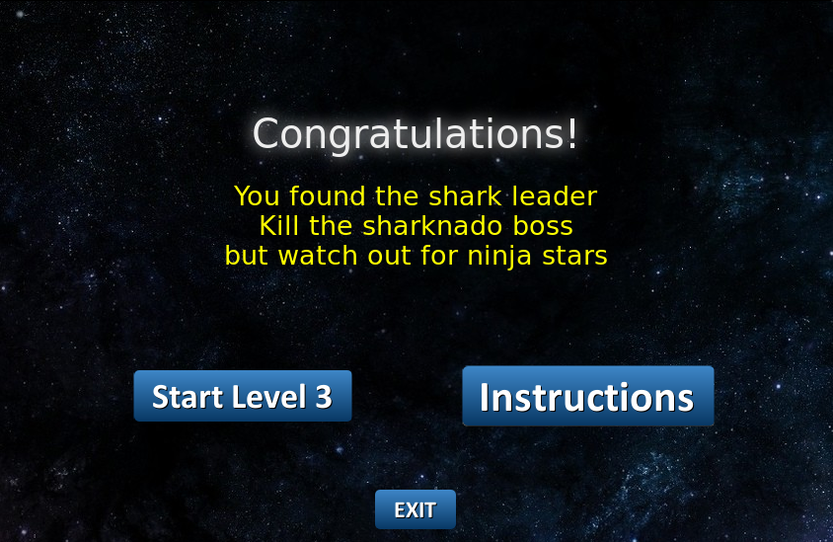

Level 3
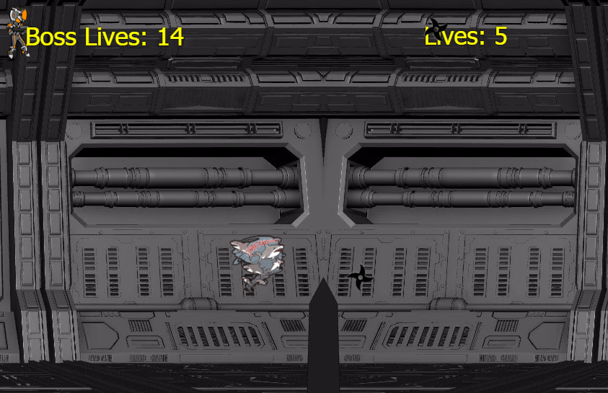

Losing Scene
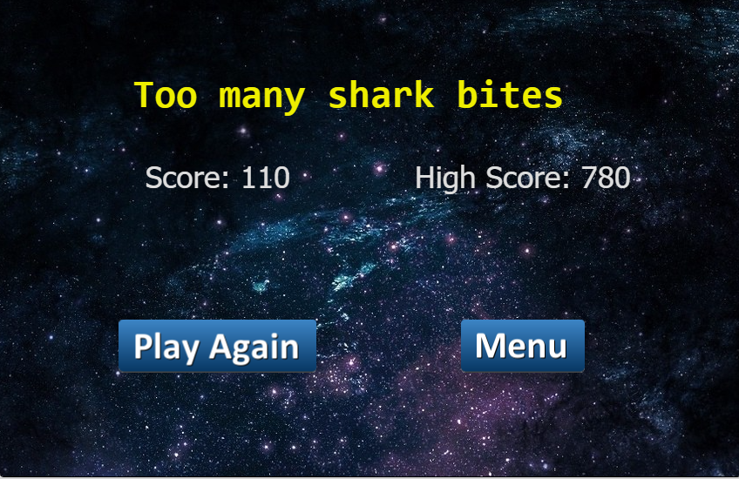

Winning Scene
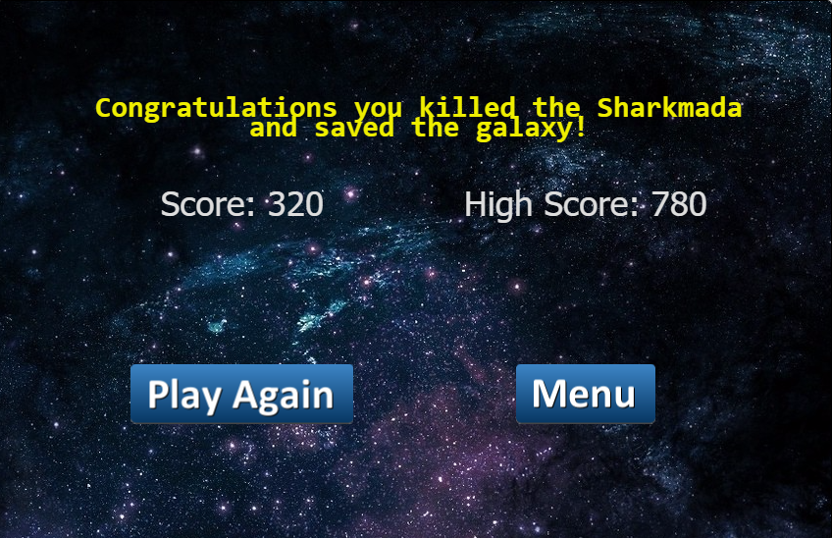

Sound Index

Level 1
- SpaceshipengineShor.mp3 - background
- Comic-bite.ogg – player collision with shark
- Death.mp3 – bullet collision with shark
- Lifeup.wav – player collision with heart
- Laser.wav – shooting of a bullet

Level 2
- Epic.mp3 - background
- Comic-bite.ogg – player collision with shark
- Death.mp3 – bullet collision with shark
- Thankyou.mp3 – player collision with injured person
- Laser.wav – shooting of a bullet

Level 3
- Level3_music.ogg
- Death.mp3
- Laser.wav

Art/Multimedia Index

Level 1
- Bg.jpg – background
- Bullet.png – bullet avatar
- Spaceship.png – player avatar
- Treasure.png- heart
- Shark.png – enemy character

Level 2
- Spaceshipinterior.jpg – background
- Player_level3.png – player avatar
- Injured.png – injured person
- Shark.png – enemy character
- Bulletplayer.gif – bullet

Level 3
- Spaceshipinterior.jpg – background
- Player_level3.png – player avatar
- Sharknadolarge.png – enemy character
- Bulletplayer.gif – bullet

Button Images
- Exitbutton.png
- Menu.png
- Instructions.png
- Playagain.png
- L2Btn.png

Game Link
Microsoft Azure: https://html5-arcade-game.azurewebsites.net/

Cheat Codes:
- Click 1 on the keyboard will take you to level 1
- Click 2 on the keyboard will take you to level 2
- Click 3 on the keyboard will take you to level 3

